NXP4330 Movie Player API for Linux
Version 0.8.0
Copyright © 2014 Nexell Co.,Ltd. All rights reserved.
NXP4330 Movie Player API for Linux
Nexell S/W Team 3
Release information
The following changes have been make to this document.
Change History
Date | Change
16 January 2014 | First release for v0.8.0

Proprietary Notice
Information in this document is provided solely to enable system and software implementers to use Nexell products. There are no express or implied copyright licenses granted hereunder to design or fabricate any integrated circuits or integrated circuits based on the information in this document.
Nexell reserves the right to make changes without further notice to any products herein.
Nexell makes no warranty, representation or guarantee regarding the suitability of its products for any particular purpose, nor does Nexell assume any liability arising out of the application or use of any product or circuit, and specifically disclaims any and all liability, including without limitation consequential or incidental damages. “Typical” parameters which may be provided in Nexell data sheets and/or specifications can and do vary in different applications and actual performance may vary over time. All operating parameters, including “Typicals” must be validated for each customer application by customer’s technical experts. Nexell does not convey any license under its patent rights nor the rights of others. Nexell products are not designed, intended, or authorized for use as components in systems intended for surgical implant into the body, or other applications intended to support or sustain life, or for any other application in which the failure of the Nexell product could create a situation where personal injury or death may occur. Should Buyer purchase or use Nexell products for any such unintended or unauthorized application, Buyer shall indemnify and hold Nexell and its officers, employees, subsidiaries, affiliates, and distributors harmless against all claims, costs, damages, and expenses, and reasonable attorney fees arising out of, directly or indirectly, any claim of personal injury or death associated with such unintended or unauthorized use, even if such claim alleges that Nexell was negligent regarding the design or manufacture of the part.

Copyrightⓒ 2009~2014 Nexell Co.,Ltd. All rights reserved.
No part of this publication may be reproduced, stored in a retrieval system, or transmitted in any form or by any means, electric or mechanical, by photocopying, recording, or otherwise, without the prior written consent of Nexell.

Contact us
[463-825] Bundang yemizi Bldg. 1202, 6-5 Sunae-dong, Bundang-gu, Sungnam-city, Gyeonggi-do, Korea.
TEL: 82-31-698-7400
FAX:82-31-698-7455
http://www.nexell.co.kr

Contents
Chap 1. Overview 1
1.1 Overview 1
1.2 Environment 1
Chap 2. APIs 2
2.1 Overview 2
2.2 API Details 2
Chap 3. State Diagram 7
3.1 Media Player State Diagram 7
Chap 4. 지원 범위 8
4.1 지원 가능한 format. 8
4.2 Known Issues 9

Overview

Overview
이 문서는 NXP4330 Linux 환경에서 각종 동영상 및 음악 파일을 재생하기 위한 API의 사용법을 설명한 문서이다.

Environment
이 API의 동작 환경은 다음과 같다.
- NXP4330 D/Q
- Linux Kernel Version 3.4.5+
- G-Streamer 0.10 Plug-In 포함된 root file system.
- G-Streamer video decoder plug-In
  - “libgstnxvideodec.so”
- G-Streamer video sink Plug-In
  - “libgstnxvideosink.so”
- Video en/decoder firmware & library.
  - “nx_vpu.ko”
  - “libnxvpu.so”
- ION memory allocator library.
  - “libnxvmem.so”
- V4L2 device driver & related libraries.
  - “libnxv4l2.so”
  - “libnxdsp.so”

APIs

Overview
API 에 대한 세부 설명이다.

API Details

NX_MPOpen
Description:
This function creates the memory,initializes the handle.
Prototype:
MP_RET NX_MPOpen( MP_HANDLE *handle, const char *uri ,
int volume, int dspModule, int dspPort,
void (*cb)(void *owner, unsigned int msg, unsigned int param1, unsigned int param2), void *cbPrivate);
Parameters;
MP_HANDKE handle : Movie player handle (input/output).
const char *uri : File name or URL. (input)
int volume : Default volume (input)
int dspModule: display Module. (input) : MLC0➔0, MLC1➔1
int dspPort : display port. (input): LCD➔0, HDMI➔1
void (*cb) :callback function(input) : End Of Stream 이 발생했을 때 callback function 을 통해 EOS 메시지가 전달된다.
void *cbPrivate: callback private data

Return value:
Error Code.

enum{
ERROR_NONE = 0,
ERROR = -1,
ERROR_HANDLE = -2,
ERROR_NOT_SUPPORT_CONTENTS = -3
}; //ErrorCode

NX_MPClose
Description:
This function frees the memory.
Prototype:
void NX_MPClose( MP_HANDLE handle );
Parameters:
MP_HANDLE handle: Movie player handle (input/output)
Return value:
None.

NX_MPGetMediaInfo
Description: Media Information
This function gets media information.( Not Available )
Prototype:
MP_RESULT NX_MPGetMediaInfo(
MP_HANDLE handle, (input/output)
int index, (input)
MP_MEDIA_INFO *pInfo (output) );
Parameters:
MP_HANDLE handle: Movie player handler.
int index : Media index.
MP_MEDIA_INFO *pInfo : 해당 index에 따른 media information.
Return value:
If exist media information for each indexes, return ERROR_NONE. Otherwise return ERROR.

typedef struct MP_MEDIA_INFO {
unsigned long VDuration;
unsigned long Framerate;
unsigned long Width;
unsigned long Height;
unsigned long ADuration;
unsigned long samplerate;
unsigned long channels;
unsigned long bitrate;
} MP_MEDIA_INFO

NX_MPPlay
Description:
This function starts the play.
Prototype:
MP_RESULT NX_MPPlay( MP_HANDLE handle, float speed );
Parameters:
MP_HANDLE handle: Movie player handler. (input)
float speed : playing speed. The value 1.0 means normal speed. (other value not support yet)
(This functionality is not available yet.)
Return value:
If success returns ERROR_NONE, otherwise returns ERROR.

NX_MPPause
Description:
This function pauses the play.
Prototype:
MP_RESULT NX_MPPause(MP_HANDLE hande);
Parameter:
MP_HANDLE handle: Movie player handler.(input)
Return value:
If success returns ERROR_NONE, otherwise returns ERROR.

NX_MPStop
Description: Media
This function stops the play.
Prototype:
MP_RESULT NX_MPStop(MP_HANDLE hande);
Parameter:
MP_HANDLE handle: Movie player handler. (input)
Return value:
If success returns ERROR_NONE, otherwise returns ERROR.

NX_MPSeek
Description:
This function seeks the play.
Prototype:
MP_RESULT NX_MPSeek(MP_HANDLE hande, unsigned int seekTime);
Parameter:
MP_HANDLE handle: Movie player handler. (input)
unsigned int seekTime: Seek time in milli-seconds. (input)
Return value:
If success returns ERROR_NONE, otherwise returns ERROR.

NX_MPGetCurDuration
Description:
This function gets media duration.
Prototype:
MP_RESULT NX_MPGetCurDuration(MP_HANDLE handle, unsigned int *duration)
Parameters:
MP_HANDLE handle: Movie player handler. (input)
unsigned int *duration: Contents duration in milli-seconds. (output)
Return value:
If success returns ERROR_NONE, otherwise returns ERROR.

NX_MPGetCurPosition
Description:
This function gets current position.
Prototype:
MP_RESULT NX_MPGetCurPosition(MP_HANDLE handle, unsigned int *position)
Parameters:
MP_HANDLE handle: Movie player handler. (input)
unsigned int *position: Current play time in milli-seconds. (output)
Return value:
If success returns ERROR_NONE, otherwise returns ERROR.

NX_MPSetDspPosition
Description:
This function adjusts display position.
Prototype:
MP_RESULT NX_MPSetDspPosition(
MP_HANDLE handle,
int dspModule,
int dspPort,
int x,
int y,
int w,
int h
);
Parameters:
MP_HANDLE handle: Movie player handler. (input)
int dspModule: Display module. (input) : MLC0➔0, MLC1➔1
int dspPort Display port. (input) : LCD➔0, HDMI➔1
int x: screen X position. (input)
int y: screen Y position. (input)
int w: Display width. (input)
int h: Display height. (input)
( * dspModule & dspPort 값이 최초 initialize 할 때의 값과 같을 경우에만 정상적으로 설정이 가능함. )
Return value:
If success returns ERROR_NONE, otherwise return ERROR.

NX_MPSetVolume
Description:
This function adjusts audio volume.
Prototype:
MP_RESULT NX_MPSetVolume(MP_HANDLE handle, int volume);
Parameters:
MP_HANDLE handle: Movie player handler. (input)
int volume: Volume value.(range 0 ~ 100, 0 means mute) (input)
Return value:
If success return ERROR_NONE, otherwise return ERROR.

State Diagram

Media Player State Diagram

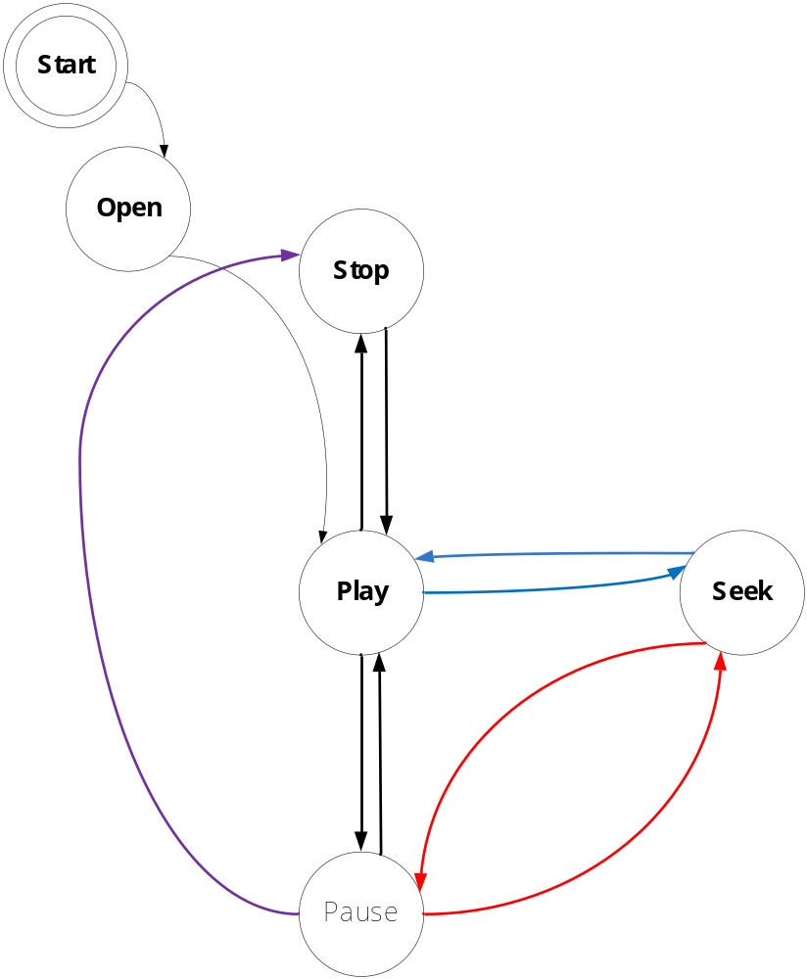

지원 범위

지원 가능한 format.

Container Types
Container | Support
ASF | O
AVI | O
MKV | O
MP4 | O
OGG | O
RM(RealMdeia) | O
FLV | O
MPEG-PS | X
MPEG-TS | X

Video Codec Types
Video Decoder | Support
H.264 | O
H.263 | O
MPEG4 | O
FLV | O
RealVideo | O
MPEG4-ASP (include XVID) | O
VC1(WMV9) | O
Theora | O
MPEG2 | X

Audio Codec Types
Audio Decoder | Support
MP3 | O
AAC | O
AC3 | X
OGG | X
RealAudio | X
WMA | X
FLAC | X

Known Issues
- Audio 전용 파일은 현재 지원하지 않음.(향후 지원 예정 임)

